CS-340-T5534 Client/Server Development 23EW5

1-3 Assignment: Intro to MongoDB

Jacob Simmons, 04 May 2023

* Verify Access to Mongo Shell

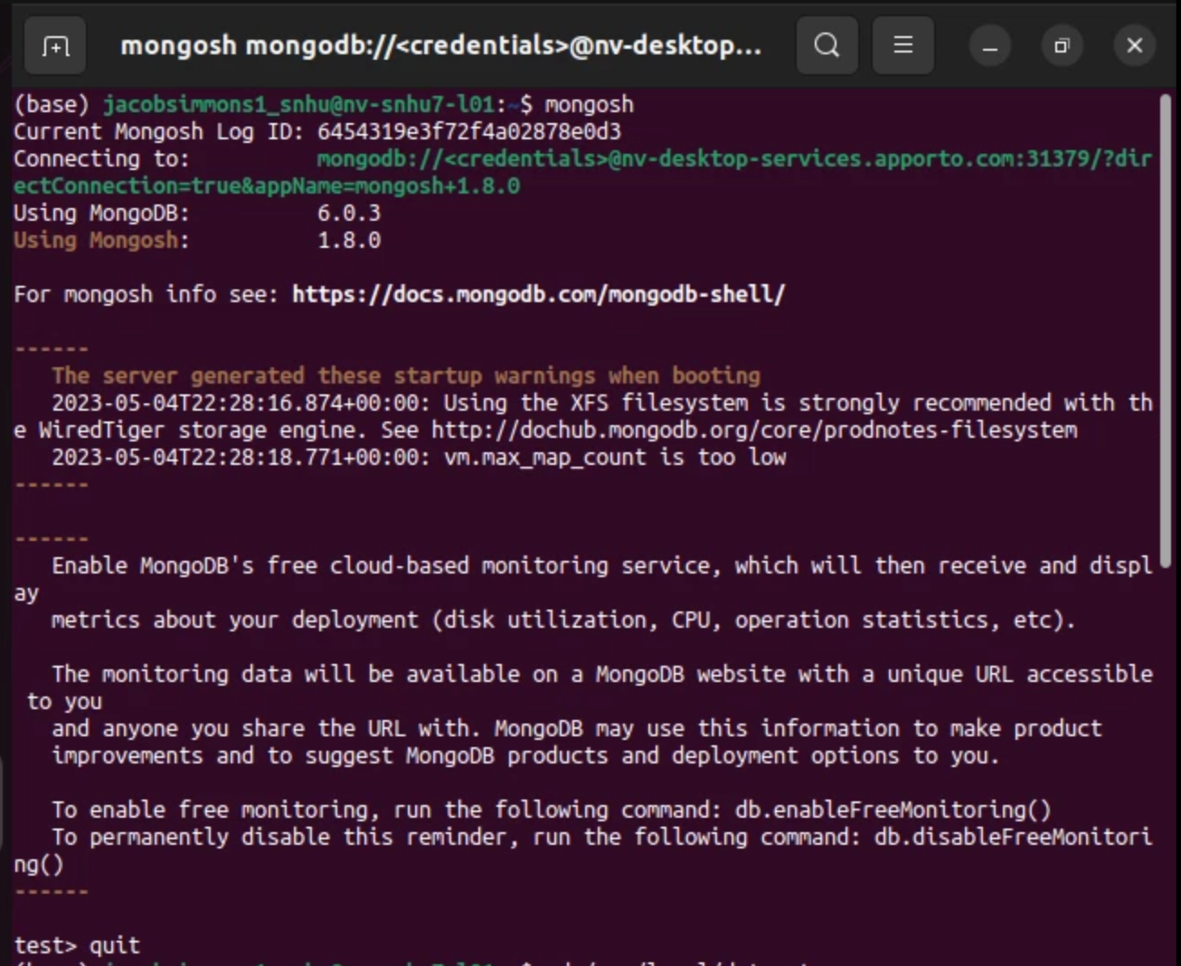

* Load Database in Linux Shell

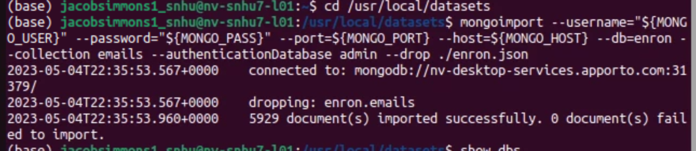

* Retrieve document from MongoShell and execute commands

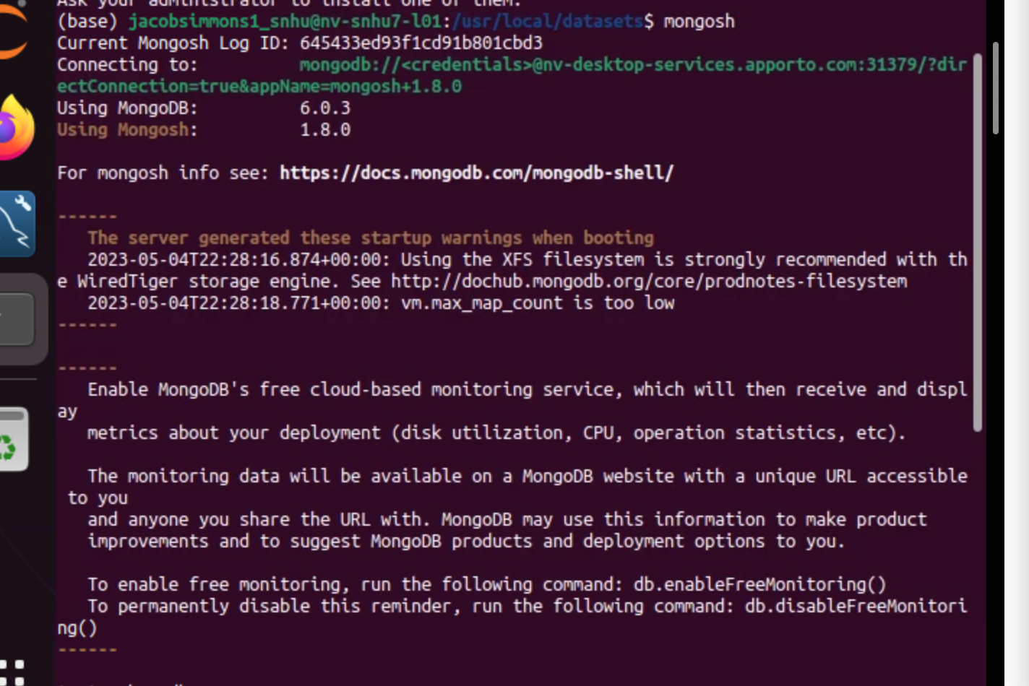

* + show dbs, use enron, show collections, db.emails.findOne()

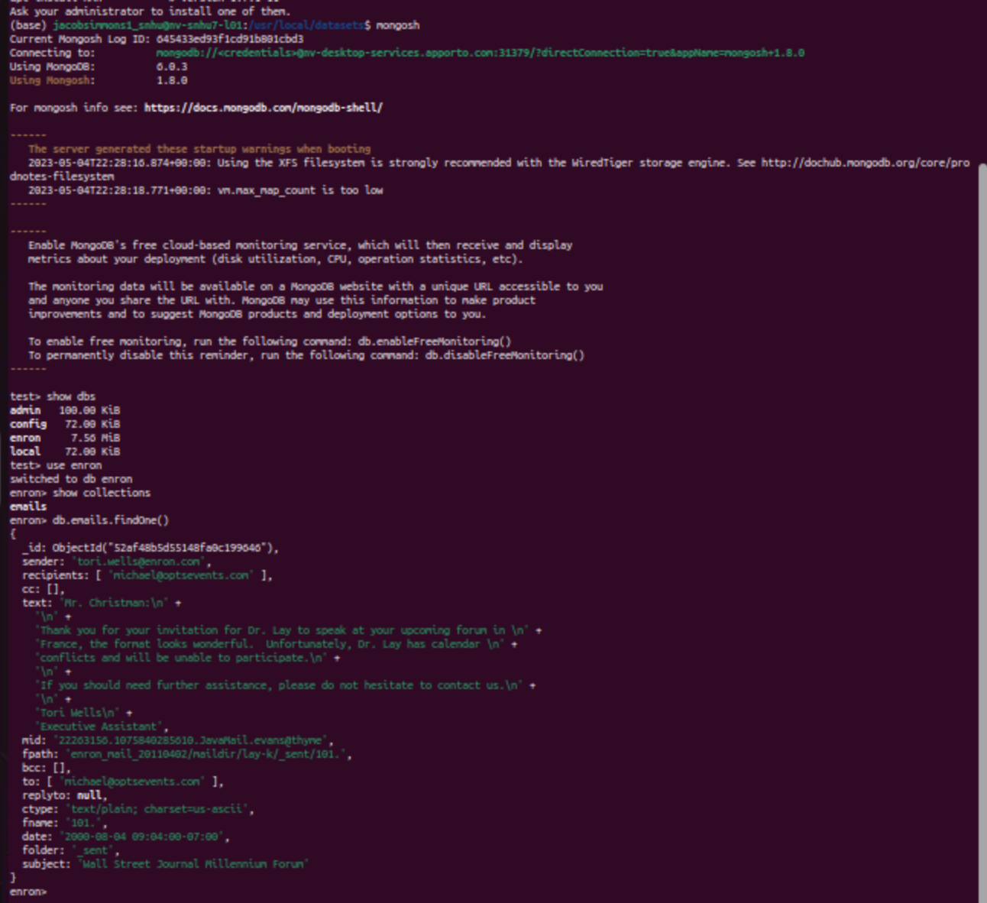

* Show the size of a single document (very bottom of screenshot)

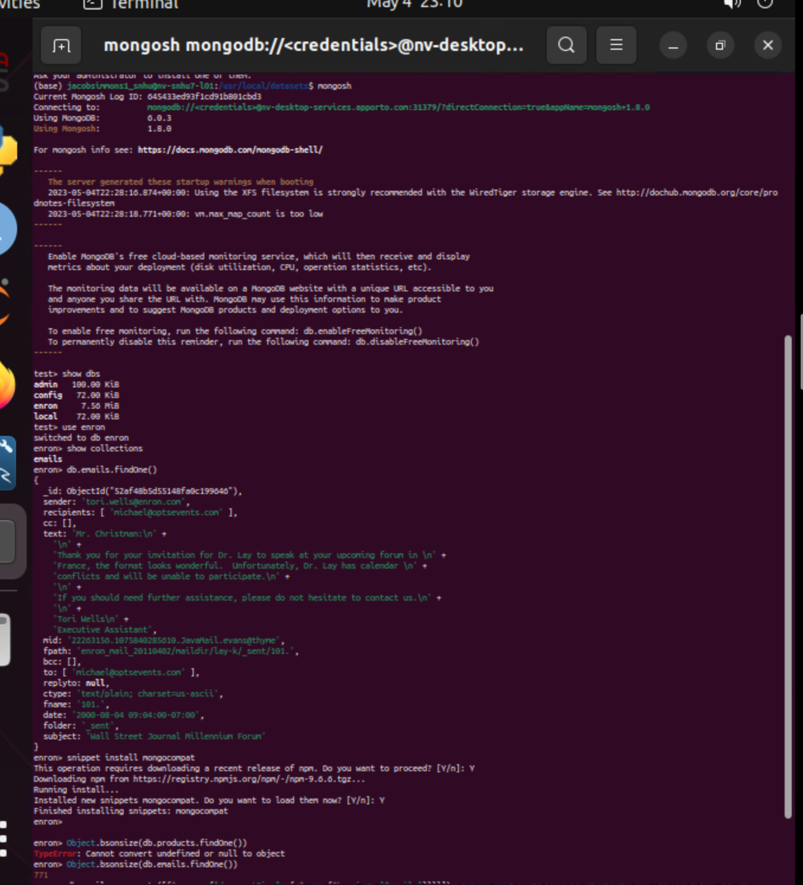

* Find size of the collection of documents (very bottom of screenshot)

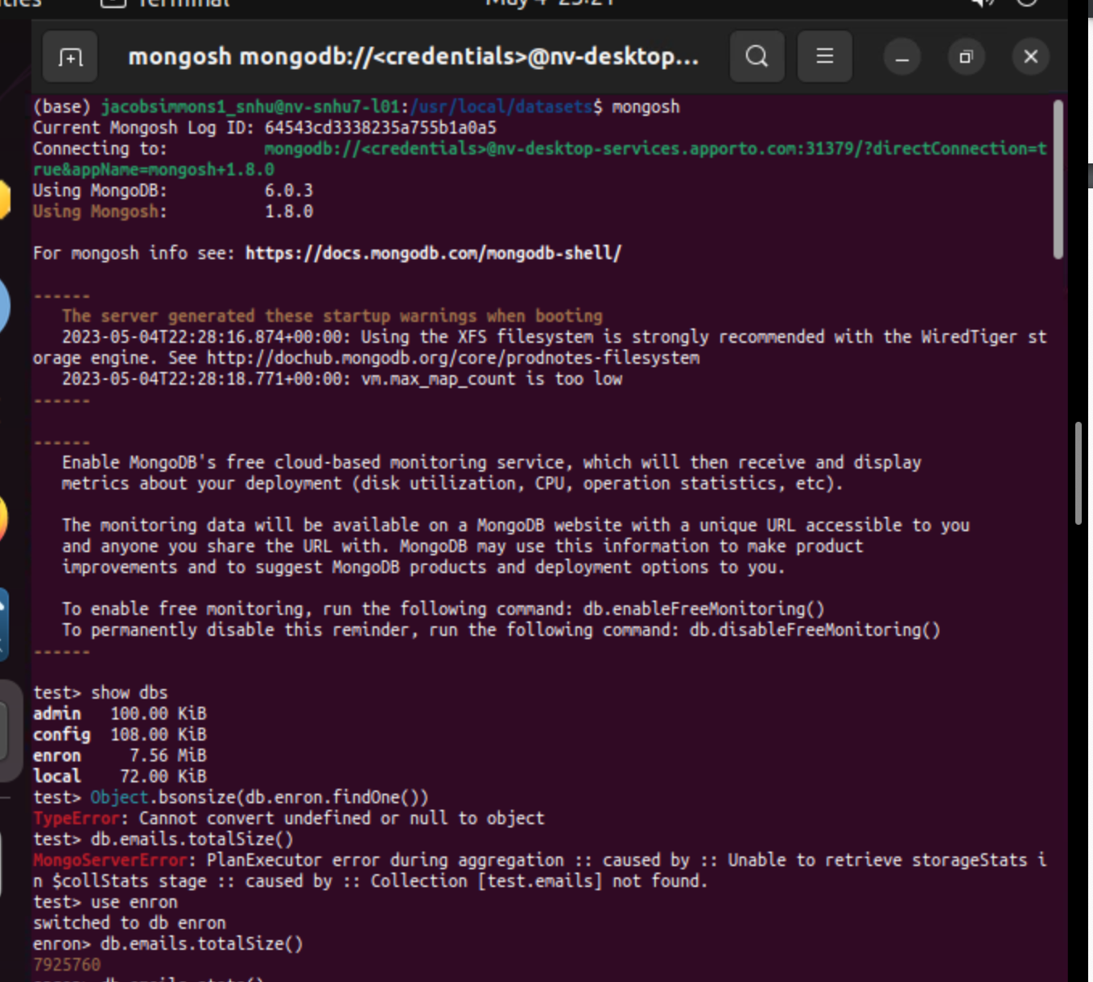

**References**

None